# Section III: Database Implementation

## 3.1 Physical Database Design

## 3.1.1 DDL SQL: Write SQL to CREATE DATABASE and Table

**CREATE DATABASE LIFETIME_FITNESS;**

**Membership**

CREATE TABLE Membership (

planID int(50) NOT NULL,

planName varchar(20) NOT NULL,

membershipRate float(50) NOT NULL,

signUpFee float(20) NOT NULL,

durationMonths int(5) NOT NULL,

planType varchar(10) NOT NULL,

CONSTRAINT planID_PK1 PRIMARY KEY(planID));

**MEMBER**

CREATE TABLE Member (

memberID int(50) NOT NULL,

memberFirstName varchar(20) NOT NULL,

memberLastName varchar(20) NOT NULL,

DOB date NOT NULL,

phoneNumber varchar(20) NOT NULL,

emailAddress varchar(20) NOT NULL,

userName varchar(20) AS (memberFirstName),

joinDate date NOT NULL,

planID int(50) NOT NULL,

aptNo varchar(20) NOT NULL,

street varchar(20) NOT NULL,

city varchar(20) NOT NULL,

state varchar(20) NOT NULL,

zip varchar(20) NOT NULL,

CONSTRAINT memberID_PK2 PRIMARY KEY(memberID),

CONSTRAINT planID_FK1 FOREIGN KEY(planID) REFERENCES membership(planID));

**GYM MEMBERSHIP**

CREATE TABLE GYM_Membership (

gplanID int(50) NOT NULL,

equipmentSeries varchar(20) NOT NULL,

floorNo int(10) NOT NULL,

CONSTRAINT gplanID_PK3 PRIMARY KEY(gplanID),

CONSTRAINT planID_FK2 FOREIGN KEY(gplanID) REFERENCES membership(planID));

**SPA MEMBERSHIP**

CREATE TABLE SPA_Membership (

splanID int(50) NOT NULL,

service varchar(20) NOT NULL,

CONSTRAINT splanID_PK4 PRIMARY KEY(splanID),

CONSTRAINT planID_FK3 FOREIGN KEY(splanID) REFERENCES membership(planID));

**WORKOUT SESSION**

CREATE TABLE Workout_Session (

workoutID int(50) NOT NULL,

workoutTime varchar(15) NOT NULL,

duration int(2) NOT NULL,

days varchar(15) NOT NULL,

description varchar(50) NOT NULL,

workoutType varchar(50) NOT NULL,

CONSTRAINT workoutID_PK5 PRIMARY KEY(workoutID));

**GROUP CLASS**

CREATE TABLE Group_Class (

gworkoutID int(50) NOT NULL,

className varchar(20) NOT NULL,

classSize int(5) NOT NULL,

roomNumber int(5) NOT NULL,

CONSTRAINT gworkoutID_PK6 PRIMARY KEY(gworkoutID),

CONSTRAINT workoutID_FK4 FOREIGN KEY(gworkoutID) REFERENCES workout_session(workoutID));

**INDIVIDUAL SESSION**

CREATE TABLE Individual_Session (

iworkoutID int(50) NOT NULL,

roomName varchar(20) NOT NULL,

CONSTRAINT iworkoutID_PK7 PRIMARY KEY(iworkoutID),

CONSTRAINT workoutID_FK5 FOREIGN KEY(iworkoutID) REFERENCES workout_session(workoutID));

**RESERVATION**

CREATE TABLE Reservation (

reservationID int(50) NOT NULL,

reservationDate date NOT NULL,

memberID int(50) NOT NULL,

workoutID int(50) NOT NULL,

CONSTRAINT reservationID_PK8 PRIMARY KEY(reservationID),

CONSTRAINT workoutID_FK6 FOREIGN KEY(workoutID) REFERENCES workout_session(workoutID),

CONSTRAINT memberID_FK7 FOREIGN KEY(memberID) REFERENCES member(memberID));

**TRAINER**

CREATE TABLE Trainer (

trainerID int(50) NOT NULL,

trainerName varchar(100) NOT NULL,

phoneNumber varchar(50) NOT NULL,

emailAddress varchar(50) NOT NULL,

address varchar(150) NOT NULL,

salary float(10) NOT NULL,

joinDate date NOT NULL,

sessionID int(50) NOT NULL,

CONSTRAINT trainerID_PK9 PRIMARY KEY(trainerID),

CONSTRAINT workoutID_FK8 FOREIGN KEY(sessionID) REFERENCES workout_session(workoutID));

**CANCELLATION**

CREATE TABLE Cancellation (

cancellationID int(50) NOT NULL,

cancellationDate date NOT NULL,

reason varchar(150) NOT NULL,

finalDecision varchar(100) DEFAULT NULL,

memberID int(50) NOT NULL,

CONSTRAINT cancellationID_PK10 PRIMARY KEY(cancellationID),

CONSTRAINT memberID_FK9 FOREIGN KEY(memberID) REFERENCES member(memberID));

**RATE CHART**

CREATE TABLE Rate_Chart (

rateID int(50) NOT NULL,

revisedMembershipRate float(50) NOT NULL,

revisedPlan varchar(10) NOT NULL,

planID int(50) NOT NULL,

CONSTRAINT rateID_PK11 PRIMARY KEY(rateID),

CONSTRAINT planID_FK10 FOREIGN KEY(planID) REFERENCES membership(planID));

**RATE CANCELLATION**

CREATE TABLE Rate_Cancellation (

rCancellationID int(50) NOT NULL,

preferredRate float NOT NULL,

rateID int(50) NOT NULL,

CONSTRAINT rCancellationID_PK12 PRIMARY KEY(rCancellationID),

CONSTRAINT rateID_FK11 FOREIGN KEY(rateID) REFERENCES rate_chart(rateID));

**MANAGER**

CREATE TABLE Manager (

managerID int(50) NOT NULL,

managerName varchar(20) NOT NULL,

contactNumber varchar(20) NOT NULL,

email varchar(20) NOT NULL,

CONSTRAINT managerID_PK13 PRIMARY KEY(managerID));

**DISSATISFACTION CANCELLATION**

CREATE TABLE Dissatisfaction_Cancellation (

dCancellationID int(50) NOT NULL,

message varchar(200) NOT NULL,

managerID int(50) NULL,

CONSTRAINT dCancellationID_PK14 PRIMARY KEY(dCancellationID),

CONSTRAINT managerID_FK12 FOREIGN KEY(managerID) REFERENCE manager(managerID));

**GYM LOCATION**

CREATE TABLE Gym_Location (

locationID int(50) NOT NULL,

locationName varchar(200) NOT NULL,

state varchar(200) NOT NULL,

zipcode int(20) NOT NULL,

CONSTRAINT locationID_PK15 PRIMARY KEY(locationID));

**MOVE CANCELLATION**

CREATE TABLE Move_Cancellation (

mCancellationID int(50) NOT NULL,

newLocationName varchar(200) NOT NULL,

newZipCode int(20) NOT NULL,

locationID int(50) NULL,

CONSTRAINT mCancellationID_PK16 PRIMARY KEY(mCancellationID),

CONSTRAINT locationID_FK13 FOREIGN KEY(locationID) REFERENCES gym_location(locationID));

**TRANSFER**

CREATE TABLE Transfer (

transferID int(50) NOT NULL,

agreement varchar(200) NOT NULL,

moveDate Date NOT NULL,

locationID int(50) NULL,

CONSTRAINT transferID_PK17 PRIMARY KEY(transferID),

CONSTRAINT locationID_FK14 FOREIGN KEY(locationID) REFERENCES gym_location(locationID));

## 

*Figure 5: Lifetime Fitness database and tables created*

## 3.1.2 CREATE VIEWS and STORED PROCEDURE

**RATE ANALYSIS**

CREATE VIEW rateAnalysis

AS SELECT M.memberID, M.memberFirstName, C.reason,

MS.planName, MS.membershipRate, R.preferredRate, RC.revisedMembershipRate, RC.revisedPlan, C.finalDecision

FROM member AS M INNER JOIN cancellation AS C ON M.memberID=C.memberID

INNER JOIN membership AS MS ON M.planID=MS.planID

INNER JOIN rate_chart AS RC ON MS.planID=RC.planID

INNER JOIN rate_cancellation AS R ON R.rateID=RC.rateID

AND C.reason="Rate";

**SERVICE ANALYSIS**

CREATE VIEW serviceAnalysis

AS SELECT M.memberID, M.memberFirstName, C.reason,

MS.planName, D.message, MA.managerName, MA.email, MA.contactNumber, C.finalDecision

FROM member AS M INNER JOIN cancellation AS C ON M.memberID=C.memberID

INNER JOIN membership AS MS ON M.planID=MS.planID

INNER JOIN dissatisfaction_cancellation AS D ON D.dCancellationID=C.cancellationID

INNER JOIN manager AS MA ON MA.managerID=D.managerID

AND C.reason="Dissatisfaction";

**LOCATION ANALYSIS**

CREATE VIEW locationAnalysis

AS SELECT M.memberID, M.memberFirstName, C.reason,

MS.planName, L.newZipCode, L.newLocationName, GL.state,GL.locationName, C.finalDecision

FROM member AS M INNER JOIN cancellation AS C ON M.memberID=C.memberID

INNER JOIN membership AS MS ON M.planID=MS.planID

INNER JOIN move_cancellation AS L ON L.mCancellationID=C.cancellationID

INNER JOIN gym_location AS GL ON GL.locationID=L.locationID

AND C.reason="Move";

**STORED PROCEDURE- GYM OPERATIONS**

DELIMITER $$

CREATE PROCEDURE LIFETIME_FITNESS.SP_TRAINER_PERFORMANCE1

(IN DMESSAGE VARCHAR(200))

BEGIN

SELECT M.userName, MS.planName, M.joinDate, MS.planType, C.cancellationDate, D.message, R.reservationDate, W.description,W.workoutType,

T.trainerName,T.joinDate,T.phoneNumber,T.salary

FROM member AS M INNER JOIN membership AS MS ON M.planID=MS.planID

LEFT JOIN cancellation AS C ON C.memberID=M.memberID

LEFT JOIN dissatisfaction_cancellation AS D ON D.dCancellationID=C.cancellationID

LEFT JOIN reservation AS R ON R.memberID=M.memberID

LEFT JOIN workout_session AS W ON W.workoutID=R.workoutID

LEFT JOIN TRAINER AS T ON T.sessionID=W.workoutID

WHERE D.message=DMESSAGE;

END$$

DELIMITER ;

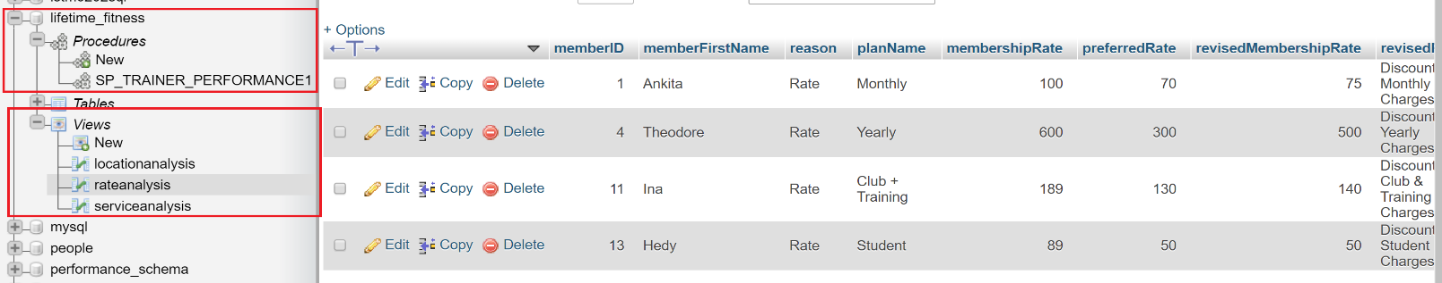

*Figure 6: Lifetime Fitness views and stored procedure created*

## 3.2 CREATE DATABASE

## 3.2.1 DML SQL: Write SQL to INSERT data INTO TABLE

**MEMBERSHIP (10 Records)**

INSERT INTO Membership(planID,planName,membershipRate,signUpFee,durationMonths, planType) VALUES (1,'Monthly',100,50,1,'Gym and Spa');

INSERT INTO Membership(planID,planName,membershipRate,signUpFee,durationMonths, planType) VALUES (2,'Quarterly',250,50,3,'Gym and Spa');

INSERT INTO Membership(planID,planName,membershipRate,signUpFee,durationMonths, planType) VALUES (3,'Yearly',600,150,12,'Gym and Spa');

INSERT INTO Membership(planID,planName,membershipRate,signUpFee,durationMonths, planType) VALUES (4,'Spa Access',200,50,6,'Spa');

INSERT INTO Membership(planID,planName,membershipRate,signUpFee,durationMonths, planType) VALUES (5,'Club Access',99,50,1,'Gym and Spa');

INSERT INTO Membership(planID,planName,membershipRate,signUpFee,durationMonths, planType) VALUES (6,'Club + Training',189,50,1,'Gym');

INSERT INTO Membership(planID,planName,membershipRate,signUpFee,durationMonths, planType) VALUES (7,'26 & Under',89,50,1,'Gym');

INSERT INTO Membership(planID,planName,membershipRate,signUpFee,durationMonths, planType) VALUES (8,'Student',89,50,1,'Gym and Spa');

INSERT INTO Membership(planID,planName,membershipRate,signUpFee,durationMonths, planType) VALUES (9,'Couple',80,40,1,'Gym and Spa');

INSERT INTO Membership(planID,planName,membershipRate,signUpFee,durationMonths, planType) VALUES (10,'Family',150,60,1,'Gym and Spa');

**MEMBER (15 Records)**

INSERT INTO Member(memberID,memberFirstName,memberLastName,DOB,phoneNumber,emailAddress,joinDate,planID,aptNo,street,city,state,zip) VALUES(1,'Ankita','Singh','1960-07-30','(257) 563-7401','abc@gmail.com','2018-01-01',1,'111','711-2880 Nulla St.','Mankato','Mississippi','96522');

INSERT INTO Member(memberID,memberFirstName,memberLastName,DOB,phoneNumber,emailAddress,joinDate,planID,aptNo,street,city,state,zip) VALUES(2,'Iris','Watson','1961-07-30','(372) 587-2335','def@gmail.com','2016-03-02',1,'P.O. Box 283','Fusce Rd.','Frederick','Nebraska','20620');

INSERT INTO Member(memberID,memberFirstName,memberLastName,DOB,phoneNumber,emailAddress,joinDate,planID,aptNo,street,city,state,zip) VALUES(3,'Celeste','Slater','1990-04-12','(786) 713-8616','ghi@gmail.com','2019-04-12',2,'606-3727','Ullamcorper. Street','Roseville','NH','11523');

INSERT INTO Member(memberID,memberFirstName,memberLastName,DOB,phoneNumber,emailAddress,joinDate,planID,aptNo,street,city,state,zip) VALUES(4,'Theodore','Lowe','2000-12-01','(793) 151-6230','Lowe@gmail.com','2015-03-05',3,'Ap #867-859','Sit Rd.','Azusa','New York','39531');

INSERT INTO Member(memberID,memberFirstName,memberLastName,DOB,phoneNumber,emailAddress,joinDate,planID,aptNo,street,city,state,zip) VALUES(5,'Calista','Wise','1998-03-09','(492) 709-6392','wise@gmail.com','2019-05-12',7,'7292','Dictum Av.','San Antonio','MI','47096');

INSERT INTO Member(memberID,memberFirstName,memberLastName,DOB,phoneNumber,emailAddress,joinDate,planID,aptNo,street,city,state,zip) VALUES(6,'Kyla','Olsen','1985-02-22','(654) 393-5734','olsen@gmail.com','2019-03-05',10,'Ap #651-8679','Sodales Av.','Tamuning','PA','10855');

INSERT INTO Member(memberID,memberFirstName,memberLastName,DOB,phoneNumber,emailAddress,joinDate,planID,aptNo,street,city,state,zip) VALUES(7,'Forrest','Ray','1995-05-20','(404) 960-3807','ray@gmail.com','2019-05-23',8,'191-103',' Integer Rd.','Corona','New Mexico','8219');

INSERT INTO Member(memberID,memberFirstName,memberLastName,DOB,phoneNumber,emailAddress,joinDate,planID,aptNo,street,city,state,zip) VALUES(8,'Hiroko','Potter','1993-06-13','(314) 244-6306','potter@gmail.com','2018-02-04',9,'P.O. Box 887 2508','Dolor. Av.','Muskegon','KY','12482');

INSERT INTO Member(memberID,memberFirstName,memberLastName,DOB,phoneNumber,emailAddress,joinDate,planID,aptNo,street,city,state,zip) VALUES(9,'Nyssa','Vazquez','2001-01-01','(947) 278-5929','nya@gmail.com','2018-04-07',4,'511-5762','At Rd.','Chelsea','MI','67708');

INSERT INTO Member(memberID,memberFirstName,memberLastName,DOB,phoneNumber,emailAddress,joinDate,planID,aptNo,street,city,state,zip) VALUES(10,'Lawrence','Moreno','1999-10-23','(684) 579-1879','moreno@gmail.com','2017-12-12',5,'935-9940','Tortor. Street','Santa Rosa','MN','98804');

INSERT INTO Member(memberID,memberFirstName,memberLastName,DOB,phoneNumber,emailAddress,joinDate,planID,aptNo,street,city,state,zip) VALUES(11,'Ina','Moran','1989-03-14','(389) 737-2852','ina@gmail.com','2018-03-14',6,'P.O. Box 929 4189','Nunc Road','Lebanon','KY','69409');

INSERT INTO Member(memberID,memberFirstName,memberLastName,DOB,phoneNumber,emailAddress,joinDate,planID,aptNo,street,city,state,zip) VALUES(12,'Aaron','Hawkins','1989-04-01','(660) 663-4518','hawk@gmail.com','2019-04-05',8,'5587','Nunc. Avenue','Erie','Rhode Island','24975');

INSERT INTO Member(memberID,memberFirstName,memberLastName,DOB,phoneNumber,emailAddress,joinDate,planID,aptNo,street,city,state,zip) VALUES(13,'Hedy','Greene','1990-09-26','(608) 265-2215','greene@gmail.com','2017-02-12',8,'Ap #696-3279','Viverra. Avenue','Latrobe','DE','38100');

INSERT INTO Member(memberID,memberFirstName,memberLastName,DOB,phoneNumber,emailAddress,joinDate,planID,aptNo,street,city,state,zip) VALUES(14,'Melvin','Porter','1994-06-11','(959) 119-8364','porter@gmail.com','2018-02-12',8,'P.O. Box 132 1599','Curabitur Rd.','Bandera','South Dakota','45149');

INSERT INTO Member(memberID,memberFirstName,memberLastName,DOB,phoneNumber,emailAddress,joinDate,planID,aptNo,street,city,state,zip) VALUES(15,'Keefe','Sellers','1996-07-30','(468) 353-2641','seller@gmail.com','2019-12-23',7,'347-7666','Iaculis St.','Woodruff','SC','49854');

**GYM MEMBERSHIP (9 Records)**

INSERT INTO gym_membership(gplanID,equipmentSeries,floorNo) VALUES(1,'1-20',1);

INSERT INTO gym_membership(gplanID,equipmentSeries,floorNo) VALUES(2,'21-26',2);

INSERT INTO gym_membership(gplanID,equipmentSeries,floorNo) VALUES(3,'27-31',1);

INSERT INTO gym_membership(gplanID,equipmentSeries,floorNo) VALUES(5,'32-36',2);

INSERT INTO gym_membership(gplanID,equipmentSeries,floorNo) VALUES(6,'37-40',1);

INSERT INTO gym_membership(gplanID,equipmentSeries,floorNo) VALUES(7,'41-45',2);

INSERT INTO gym_membership(gplanID,equipmentSeries,floorNo) VALUES(8,'46-48',1);

INSERT INTO gym_membership(gplanID,equipmentSeries,floorNo) VALUES(9,'49-51',2);

INSERT INTO gym_membership(gplanID,equipmentSeries,floorNo) VALUES(10,'52-54',1);

**SPA MEMBERSHIP (8 Records)**

INSERT INTO spa_membership(splanID,service) VALUES(1,'Massage-Time Based');

INSERT INTO spa_membership(splanID,service) VALUES(2,'Nail Care-Time Based');

INSERT INTO spa_membership(splanID,service) VALUES(3,'Hair Care-Time Based');

INSERT INTO spa_membership(splanID,service) VALUES(4,'Skin Care-Time Based');

INSERT INTO spa_membership(splanID,service) VALUES(5,'Massage-Guest Based');

INSERT INTO spa_membership(splanID,service) VALUES(8,'Me-Time-Time Based');

INSERT INTO spa_membership(splanID,service) VALUES(9,'Nail Care- Guest Based');

INSERT INTO spa_membership(splanID,service) VALUES(10,'Hair Care-Guest Based');

**WORKOUT SESSION (26 Records)**

INSERT INTO workout_session(workoutID,workoutTime,duration,days,description,workoutType) VALUES(1,'5:30 AM',1,'Monday','PWR Cycle','Group Class');

INSERT INTO workout_session(workoutID,workoutTime,duration,days,description,workoutType) VALUES(2,'7:15 AM',0.75,'Monday','H.I.I.T','Group Class');

INSERT INTO workout_session(workoutID,workoutTime,duration,days,description,workoutType) VALUES(3,'8:30 AM',0.75,'Monday','Barbell Strength','Group Class');

INSERT INTO workout_session(workoutID,workoutTime,duration,days,description,workoutType) VALUES(4,'9:30 AM',1,'Monday','SOL','Group Class');

INSERT INTO workout_session(workoutID,workoutTime,duration,days,description,workoutType) VALUES(5,'9:45 AM',0.75,'Monday','EDG Cycle','Group Class');

INSERT INTO workout_session(workoutID,workoutTime,duration,days,description,workoutType) VALUES(6,'10 AM',0.5,'Monday','Discover Pilates','Group Class');

INSERT INTO workout_session(workoutID,workoutTime,duration,days,description,workoutType) VALUES(7,'11 AM',1,'Monday','Surrender','Group Class');

INSERT INTO workout_session(workoutID,workoutTime,duration,days,description,workoutType) VALUES(8,'5:30 PM',0.75,'Monday','Zumba','Group Class');

INSERT INTO workout_session(workoutID,workoutTime,duration,days,description,workoutType) VALUES(9,'7 PM',1,'Monday','Surrender','Group Class');

INSERT INTO workout_session(workoutID,workoutTime,duration,days,description,workoutType) VALUES(10,'7:15 AM',0.75,'Tuesday','SHRED','Group Class');

INSERT INTO workout_session(workoutID,workoutTime,duration,days,description,workoutType) VALUES(11,'8:30 AM',0.75,'Tuesday','EDG Sculpt','Group Class');

INSERT INTO workout_session(workoutID,workoutTime,duration,days,description,workoutType) VALUES(12,'8:30 AM',1,'Tuesday','Pilates Fusion','Group Class');

INSERT INTO workout_session(workoutID,workoutTime,duration,days,description,workoutType) VALUES(13,'9:30 AM',1,'Tuesday','Strictly Strength','Group Class');

INSERT INTO workout_session(workoutID,workoutTime,duration,days,description,workoutType) VALUES(14,'10:00 AM',1,'Tuesday','Life Barre','Individual Session');

INSERT INTO workout_session(workoutID,workoutTime,duration,days,description,workoutType) VALUES(15,'11:00 AM',0.75,'Tuesday','Core Pilates','Individual Session');

INSERT INTO workout_session(workoutID,workoutTime,duration,days,description,workoutType) VALUES(16,'4:45 PM',1,'Tuesday','ROOT','Individual Session');

INSERT INTO workout_session(workoutID,workoutTime,duration,days,description,workoutType) VALUES(17,'5:00 PM',1,'Tuesday','GTX Conditioning','Individual Session');

INSERT INTO workout_session(workoutID,workoutTime,duration,days,description,workoutType) VALUES(18,'7:00 PM',1,'Tuesday','Dance','Individual Session');

INSERT INTO workout_session(workoutID,workoutTime,duration,days,description,workoutType) VALUES(19,'7:00 PM',1,'Tuesday','Flow Guided','Individual Session');

INSERT INTO workout_session(workoutID,workoutTime,duration,days,description,workoutType) VALUES(20,'5:30 AM',1,'Wednesday','PWR Cycle','Individual Session');

INSERT INTO workout_session(workoutID,workoutTime,duration,days,description,workoutType) VALUES(21,'8:30 AM',0.75,'Wednesday','Barbell Strength','Individual Session');

INSERT INTO workout_session(workoutID,workoutTime,duration,days,description,workoutType) VALUES(22,'9:30 AM',1,'Wednesday','ROOT','Individual Session');

INSERT INTO workout_session(workoutID,workoutTime,duration,days,description,workoutType) VALUES(23,'10:30 AM',1,'Wednesday','SURRENDER','Individual Session');

INSERT INTO workout_session(workoutID,workoutTime,duration,days,description,workoutType) VALUES(24,'4:30 AM',2,'Wednesday','Zumba','Group Class');

INSERT INTO workout_session(workoutID,workoutTime,duration,days,description,workoutType) VALUES(25,'5:30 PM',1,'Wednesday','Tabata','Group Class');

INSERT INTO workout_session(workoutID,workoutTime,duration,days,description,workoutType) VALUES(26,'6:30 PM',1,'Wednesday','C.R.T.','Individual Session');

**GROUP CLASS (13 Records)**

INSERT INTO group_class(gworkoutID,className,classSize,roomNumber) VALUES(1,'Group PWR',10,1);

INSERT INTO group_class(gworkoutID,className,classSize,roomNumber) VALUES(2,'Group H.I.I.T',10,2);

INSERT INTO group_class(gworkoutID,className,classSize,roomNumber) VALUES(3,'Group Strength',20,3);

INSERT INTO group_class(gworkoutID,className,classSize,roomNumber) VALUES(4,'Group SOL',15,4);

INSERT INTO group_class(gworkoutID,className,classSize,roomNumber) VALUES(5,'Group EDG Cycle',13,5);

INSERT INTO group_class(gworkoutID,className,classSize,roomNumber) VALUES(6,'Group Pilates',12,6);

INSERT INTO group_class(gworkoutID,className,classSize,roomNumber) VALUES(7,'Group Yoga',23,1);

INSERT INTO group_class(gworkoutID,className,classSize,roomNumber) VALUES(8,'Group Zumba',11,2);

INSERT INTO group_class(gworkoutID,className,classSize,roomNumber) VALUES(9,'Meditation',23,3);

INSERT INTO group_class(gworkoutID,className,classSize,roomNumber) VALUES(10,'Group SHRED',12,4);

INSERT INTO group_class(gworkoutID,className,classSize,roomNumber) VALUES(11,'Group Sculpt',12,5);

INSERT INTO group_class(gworkoutID,className,classSize,roomNumber) VALUES(12,'Group Pilates Fusion',23,6);

INSERT INTO group_class(gworkoutID,className,classSize,roomNumber) VALUES(13,'Group Strength',12,1);

**INDIVIDUAL SESSION (11 Records)**

INSERT INTO individual_session(iworkoutID,roomName) VALUES(14,'Studio One');

INSERT INTO individual_session(iworkoutID,roomName) VALUES(15,'Pilates Room');

INSERT INTO individual_session(iworkoutID,roomName) VALUES(16,'Yoga Studio');

INSERT INTO individual_session(iworkoutID,roomName) VALUES(17,'GTX Space');

INSERT INTO individual_session(iworkoutID,roomName) VALUES(18,'Studio 1');

INSERT INTO individual_session(iworkoutID,roomName) VALUES(19,'Yoga Studio');

INSERT INTO individual_session(iworkoutID,roomName) VALUES(20,'Cycle Studio');

INSERT INTO individual_session(iworkoutID,roomName) VALUES(21,'Studio 2');

INSERT INTO individual_session(iworkoutID,roomName) VALUES(22,'Outdoors');

INSERT INTO individual_session(iworkoutID,roomName) VALUES(23,'Yoga Studio');

INSERT INTO individual_session(iworkoutID,roomName) VALUES(26,'Fitness Floor');

**RESERVATION (17 Records)**

INSERT INTO reservation(reservationID,reservationDate,memberID,workoutID) VALUES(1,'2020-10-05',1,1);

INSERT INTO reservation(reservationID,reservationDate,memberID,workoutID) VALUES(2,'2020-10-05',2,2);

INSERT INTO reservation(reservationID,reservationDate,memberID,workoutID) VALUES(3,'2020-10-05',3,3);

INSERT INTO reservation(reservationID,reservationDate,memberID,workoutID) VALUES(4,'2020-10-05',3,4);

INSERT INTO reservation(reservationID,reservationDate,memberID,workoutID) VALUES(5,'2020-10-05',3,4);

INSERT INTO reservation(reservationID,reservationDate,memberID,workoutID) VALUES(6,'2020-10-05',3,4);

INSERT INTO reservation(reservationID,reservationDate,memberID,workoutID) VALUES(7,'2020-10-05',4,5);

INSERT INTO reservation(reservationID,reservationDate,memberID,workoutID) VALUES(8,'2020-10-05',5,6);

INSERT INTO reservation(reservationID,reservationDate,memberID,workoutID) VALUES(9,'2020-10-05',6,7);

INSERT INTO reservation(reservationID,reservationDate,memberID,workoutID) VALUES(10,'2020-10-05',7,8);

INSERT INTO reservation(reservationID,reservationDate,memberID,workoutID) VALUES(11,'2020-10-05',8,9);

INSERT INTO reservation(reservationID,reservationDate,memberID,workoutID) VALUES(12,'2020-10-06',10,10);

INSERT INTO reservation(reservationID,reservationDate,memberID,workoutID) VALUES(13,'2020-10-06',11,11);

INSERT INTO reservation(reservationID,reservationDate,memberID,workoutID) VALUES(14,'2020-10-06',12,12);

INSERT INTO reservation(reservationID,reservationDate,memberID,workoutID) VALUES(15,'2020-10-06',13,14);

INSERT INTO reservation(reservationID,reservationDate,memberID,workoutID) VALUES(16,'2020-10-06',14,13);

INSERT INTO reservation(reservationID,reservationDate,memberID,workoutID) VALUES(17,'2020-10-06',15,16);

**TRAINER ((11 Records)**

INSERT INTO TRAINER(trainerID,trainerName,phoneNumber,emailAddress,address,salary,joinDate,sessionID) VALUES(2,'Tamara Howe','(655) 840-6139','we3@gmail.com','3415 Lobortis. Avenue Rocky Mount WA 48580',4300,'2016-10-06',1);

INSERT INTO TRAINER(trainerID,trainerName,phoneNumber,emailAddress,address,salary,joinDate,sessionID) VALUES(3,'Keegan Blair','(577) 333-6244','kee@gmail.com','Ap #761-2515 Egestas. Rd. Manitowoc TN 07528',4300,'2016-11-03',2);

INSERT INTO TRAINER(trainerID,trainerName,phoneNumber,emailAddress,address,salary,joinDate,sessionID) VALUES(4,'Keaton Underwood','(564) 908-6970','keaton@gmail.com','p #636-8082 Arcu Avenue Thiensville Maryland 19587',5000,'2017-04-03',3);

INSERT INTO TRAINER(trainerID,trainerName,phoneNumber,emailAddress,address,salary,joinDate,sessionID) VALUES(5,'Nasim Strong','(437) 994-5270','nasim@gmail.com','Ap #630-3889 Nulla. Street Watervliet Oklahoma 70863',5500,'2018-05-23',3);

INSERT INTO TRAINER(trainerID,trainerName,phoneNumber,emailAddress,address,salary,joinDate,sessionID) VALUES(6,'Pascale Patton','(676) 334-2174','pas@gmail.com','P.O. Box 399 4275 Amet Street West Allis NC 36734',5000,'2019-01-20',4);

INSERT INTO TRAINER(trainerID,trainerName,phoneNumber,emailAddress,address,salary,joinDate,sessionID) VALUES(7,'Ivor Delgado','(689) 721-5145','ivor@gmail.com','Ap #310-1678 Ut Av. Santa Barbara MT 88317',4000,'2020-02-13',5);

INSERT INTO TRAINER(trainerID,trainerName,phoneNumber,emailAddress,address,salary,joinDate,sessionID) VALUES(9,'Jordan Calderon','(427) 930-5255','jordan@gmail.com','430-985 Eleifend St. Duluth Washington 92611',5000,'2016-06-03',6);

INSERT INTO TRAINER(trainerID,trainerName,phoneNumber,emailAddress,address,salary,joinDate,sessionID) VALUES(10,'Zorita Anderson','(126) 940-2753','zor@gmail.com','1964 Facilisis Avenue Bell Gardens Texas 87065',5500,'2017-04-12',7);

INSERT INTO TRAINER(trainerID,trainerName,phoneNumber,emailAddress,address,salary,joinDate,sessionID) VALUES(11,'Sade Higgins','(422) 517-6053','sade@gmail.com','Ap #287-3260 Ut St. Wilmington OR 05182',4000,'2018-05-08',8);

INSERT INTO TRAINER(trainerID,trainerName,phoneNumber,emailAddress,address,salary,joinDate,sessionID) VALUES(12,'Dante Bennett','(840) 987-9449','dante@gmail.com','481-8762 Nulla Street Dearborn OR 62401',4500,'2018-07-08',9);

**CANCELLATION (10 Records)**

INSERT INTO Cancellation(cancellationID,cancellationDate,reason,finalDecision,memberID) VALUES(1,'2020-11-01','Rate','Yes, Cancel Membership',1);

INSERT INTO Cancellation(cancellationID,cancellationDate,reason,finalDecision,memberID) VALUES(2,'2020-11-02','Dissatisfaction','No, Continue Membership',2);

INSERT INTO Cancellation(cancellationID,cancellationDate,reason,finalDecision,memberID) VALUES(3,'2020-11-02','Move','Yes, Cancel Membership',3);

INSERT INTO Cancellation(cancellationID,cancellationDate,reason,finalDecision,memberID) VALUES(4,'2020-11-03','Rate','No, Continue Membership',4);

INSERT INTO Cancellation(cancellationID,cancellationDate,reason,finalDecision,memberID) VALUES(5,'2020-11-04','Dissatisfaction','No, Continue Membership',5);

INSERT INTO Cancellation(cancellationID,cancellationDate,reason,finalDecision,memberID) VALUES(6,'2020-11-04','Move','No, Continue Membership',6);

INSERT INTO Cancellation(cancellationID,cancellationDate,reason,finalDecision,memberID) VALUES(7,'2020-11-06','Dissatisfaction','Yes, Cancel Membership',10);

INSERT INTO Cancellation(cancellationID,cancellationDate,reason,finalDecision,memberID) VALUES(8,'2020-11-07','Rate','No, Continue Membership',11);

INSERT INTO Cancellation(cancellationID,cancellationDate,reason,finalDecision,memberID) VALUES(9,'2020-11-08','Dissatisfaction','Yes, Cancel Membership',12);

INSERT INTO Cancellation(cancellationID,cancellationDate,reason,finalDecision,memberID) VALUES(10,'2020-11-09','Rate','No, Continue Membership',13);

**RATE CHART (10 Records)**

INSERT INTO rate_chart(rateID,revisedMembershipRate,revisedPlan,planID) VALUES(1,75,'Discounted Monthly Charges',1);

INSERT INTO rate_chart(rateID,revisedMembershipRate,revisedPlan,planID) VALUES(2,200,'Discounted Quarterly Charges',2);

INSERT INTO rate_chart(rateID,revisedMembershipRate,revisedPlan,planID) VALUES(3,500,'Discounted Yearly Charges',3);

INSERT INTO rate_chart(rateID,revisedMembershipRate,revisedPlan,planID) VALUES(4,150,'Discounted Spa Charges',4);

INSERT INTO rate_chart(rateID,revisedMembershipRate,revisedPlan,planID) VALUES(5,50,'Discounted Club Access Charges',5);

INSERT INTO rate_chart(rateID,revisedMembershipRate,revisedPlan,planID) VALUES(6,140,'Discounted Club & Training Charges',6);

INSERT INTO rate_chart(rateID,revisedMembershipRate,revisedPlan,planID) VALUES(7,50,'Discounted 26& Under Charges',7);

INSERT INTO rate_chart(rateID,revisedMembershipRate,revisedPlan,planID) VALUES(8,50,'Discounted Student Charges',8);

INSERT INTO rate_chart(rateID,revisedMembershipRate,revisedPlan,planID) VALUES(9,50,'Discounted Couple Charges',9);

INSERT INTO rate_chart(rateID,revisedMembershipRate,revisedPlan,planID) VALUES(11,100,'Discounted Family Charges',10);

**RATE CANCELLATION (4 Records)**

INSERT INTO rate_cancellation(rCancellationID,preferredRate,rateID) VALUES(1,70,1);

INSERT INTO rate_cancellation(rCancellationID,preferredRate,rateID) VALUES(4,300,3);

INSERT INTO rate_cancellation(rCancellationID,preferredRate,rateID) VALUES(8,130,6);

INSERT INTO rate_cancellation(rCancellationID,preferredRate,rateID) VALUES(10,50,8);

**MANAGER (5 Records)**

INSERT INTO Manager(managerID,managerName,contactNumber,email) VALUES(1,'Daniel Malone','(360) 669-3923','dan@gmail.com');

INSERT INTO Manager(managerID,managerName,contactNumber,email) VALUES(2,'Emerson Espinoza','(873) 392-8802','emerson@gmail.com');

INSERT INTO Manager(managerID,managerName,contactNumber,email) VALUES(3,'Elmo Lopez','(295) 983-3476','elmo@gmail.com');

INSERT INTO Manager(managerID,managerName,contactNumber,email) VALUES(4,'Aaron Trujillo','(983) 632-8597','aaron@gmail.com');

INSERT INTO Manager(managerID,managerName,contactNumber,email) VALUES(5,'Liberty Walton','(581) 379-7573','liberty@gmail.com');

**DISSATISFACTION CANCELLATION (4 Records)**

INSERT INTO dissatisfaction_cancellation(dCancellationID,message,managerID) VALUES(2,'Billing Issue',1);

INSERT INTO dissatisfaction_cancellation(dCancellationID,message,managerID) VALUES(5,'Problems with the Service',2);

INSERT INTO dissatisfaction_cancellation(dCancellationID,message,managerID) VALUES(7,'Problems with the Product',3);

INSERT INTO dissatisfaction_cancellation(dCancellationID,message,managerID) VALUES(9,'Training Issue',4);

**GYM LOCATION (57 Records)**

INSERT INTO gym_location(locationID,locationName,state,zipcode) VALUES(1,'Vestavia Hills','Alabama',35243);

INSERT INTO gym_location(locationID,locationName,state,zipcode) VALUES(2,'Biltmore','Arizona',85016);

INSERT INTO gym_location(locationID,locationName,state,zipcode) VALUES(3,'Happy Valley-Peoria','Arizona',85383);

INSERT INTO gym_location(locationID,locationName,state,zipcode) VALUES(4,'Palm Valley','Arizona',85395);

INSERT INTO gym_location(locationID,locationName,state,zipcode) VALUES(5,'Tempe','Arizona',85284);

INSERT INTO gym_location(locationID,locationName,state,zipcode) VALUES(6,'Gilbert','Arizona',85296);

INSERT INTO gym_location(locationID,locationName,state,zipcode) VALUES(7,'North Scottsdale','Arizona',85054);

INSERT INTO gym_location(locationID,locationName,state,zipcode) VALUES(8,'Folsom','California',95630);

INSERT INTO gym_location(locationID,locationName,state,zipcode) VALUES(9,'Laguna Niguel','California',92677);

INSERT INTO gym_location(locationID,locationName,state,zipcode) VALUES(10,'Roseville','California',95661);

INSERT INTO gym_location(locationID,locationName,state,zipcode) VALUES(11,'La Jolla','California',92037);

INSERT INTO gym_location(locationID,locationName,state,zipcode) VALUES(12,'Rancho San Clemente','California',92672);

INSERT INTO gym_location(locationID,locationName,state,zipcode) VALUES(13,'Centennial','Colarado',80122);

INSERT INTO gym_location(locationID,locationName,state,zipcode) VALUES(14,'Cherry Creek','Colarado',80246);

INSERT INTO gym_location(locationID,locationName,state,zipcode) VALUES(15,'Flatirons','Colarado',80021);

INSERT INTO gym_location(locationID,locationName,state,zipcode) VALUES(16,'Westminster','Colarado',80020);

INSERT INTO gym_location(locationID,locationName,state,zipcode) VALUES(17,'Centennial Tennis','Colarado',80122);

INSERT INTO gym_location(locationID,locationName,state,zipcode) VALUES(18,'Colarado Springs','Colarado',80920);

INSERT INTO gym_location(locationID,locationName,state,zipcode) VALUES(19,'Parker-Aurora','Colarado',80138);

INSERT INTO gym_location(locationID,locationName,state,zipcode) VALUES(20,'Boca Baton','Florida',33431);

INSERT INTO gym_location(locationID,locationName,state,zipcode) VALUES(21,'Life Time Living Coral Gables','Florida',33133);

INSERT INTO gym_location(locationID,locationName,state,zipcode) VALUES(22,'Palm Beach Gardens','Florida',33410);

INSERT INTO gym_location(locationID,locationName,state,zipcode) VALUES(23,'Coral Gables','Florida',33146);

INSERT INTO gym_location(locationID,locationName,state,zipcode) VALUES(24,'Tampa','Florida',33607);

INSERT INTO gym_location(locationID,locationName,state,zipcode) VALUES(25,'Alpharetta','Georgia',30005);

INSERT INTO gym_location(locationID,locationName,state,zipcode) VALUES(26,'Peachtree Corners','Georgia',30092);

INSERT INTO gym_location(locationID,locationName,state,zipcode) VALUES(27,'Sugarloaf','Georgia',30024);

INSERT INTO gym_location(locationID,locationName,state,zipcode) VALUES(28,'John Creeks','Georgia',30097);

INSERT INTO gym_location(locationID,locationName,state,zipcode) VALUES(29,'Sandy Springs','Georgia',30342);

INSERT INTO gym_location(locationID,locationName,state,zipcode) VALUES(30,'Woodstock','Georgia',30188);

INSERT INTO gym_location(locationID,locationName,state,zipcode) VALUES(31,'Algonquin','Illinois',60102);

INSERT INTO gym_location(locationID,locationName,state,zipcode) VALUES(32,'Burr Ridge','Illinois',60527);

INSERT INTO gym_location(locationID,locationName,state,zipcode) VALUES(33,'Northbrook','Illinois',60062);

INSERT INTO gym_location(locationID,locationName,state,zipcode) VALUES(34,'Old Orchard','Illinois',60077);

INSERT INTO gym_location(locationID,locationName,state,zipcode) VALUES(35,'Schaumburg','Illinois',60173);

INSERT INTO gym_location(locationID,locationName,state,zipcode) VALUES(36,'Warrenville','Illinois',60555);

INSERT INTO gym_location(locationID,locationName,state,zipcode) VALUES(37,'Bloomingdale','Illinois',60108);

INSERT INTO gym_location(locationID,locationName,state,zipcode) VALUES(38,'Lake Zurich','Illinois',60047);

INSERT INTO gym_location(locationID,locationName,state,zipcode) VALUES(39,'Oakbrook','Illinois',60523);

INSERT INTO gym_location(locationID,locationName,state,zipcode) VALUES(40,'Orland Park','Illinois',60467);

INSERT INTO gym_location(locationID,locationName,state,zipcode) VALUES(41,'Romeoville','Illinois',60446);

INSERT INTO gym_location(locationID,locationName,state,zipcode) VALUES(42,'Vernon Hills','Illinois',60061);

INSERT INTO gym_location(locationID,locationName,state,zipcode) VALUES(43,'Castle Creek','Indiana',46250);

INSERT INTO gym_location(locationID,locationName,state,zipcode) VALUES(44,'North Meridian','Indiana',46260);

INSERT INTO gym_location(locationID,locationName,state,zipcode) VALUES(45,'Fishers','Indiana',46038);

INSERT INTO gym_location(locationID,locationName,state,zipcode) VALUES(46,'Des Moines','IOWA',50323);

INSERT INTO gym_location(locationID,locationName,state,zipcode) VALUES(47,'Lenexa','Kansas',66219);

INSERT INTO gym_location(locationID,locationName,state,zipcode) VALUES(48,'Overland Park','Kansas',66223);

INSERT INTO gym_location(locationID,locationName,state,zipcode) VALUES(49,'Columbia','Maryland',21046);

INSERT INTO gym_location(locationID,locationName,state,zipcode) VALUES(50,'Rockville','Maryland',20854);

INSERT INTO gym_location(locationID,locationName,state,zipcode) VALUES(51,'Gaithersburg','Maryland',20878);

INSERT INTO gym_location(locationID,locationName,state,zipcode) VALUES(52,'Burlington','Massachusetts',01803);

INSERT INTO gym_location(locationID,locationName,state,zipcode) VALUES(53,'MetroWest-Boston','Massachusetts',01701);

INSERT INTO gym_location(locationID,locationName,state,zipcode) VALUES(54,'Westwood','Massachusetts',02090);

INSERT INTO gym_location(locationID,locationName,state,zipcode) VALUES(55,'Chestnut Hill','Massachusetts',02467);

INSERT INTO gym_location(locationID,locationName,state,zipcode) VALUES(56,'Northshore','Massachusetts',01960);

INSERT INTO gym_location(locationID,locationName,state,zipcode) VALUES(57,'No match','No match','No match');

**MOVE CANCELLATION (2 Records)**

INSERT INTO move_cancellation(mCancellationID,newZipCode,newLocationName,locationID) VALUES(3,'20910','Silver Spring',57);

INSERT INTO move_cancellation(mCancellationID,newZipCode,newLocationName,locationID) VALUES(6,'20854','Rockville',50);

**TRANSFER (1 Record)**

INSERT INTO Transfer(transferID,agreement,moveDate,locationID) VALUES(1,'yes','2020-11-29',50);

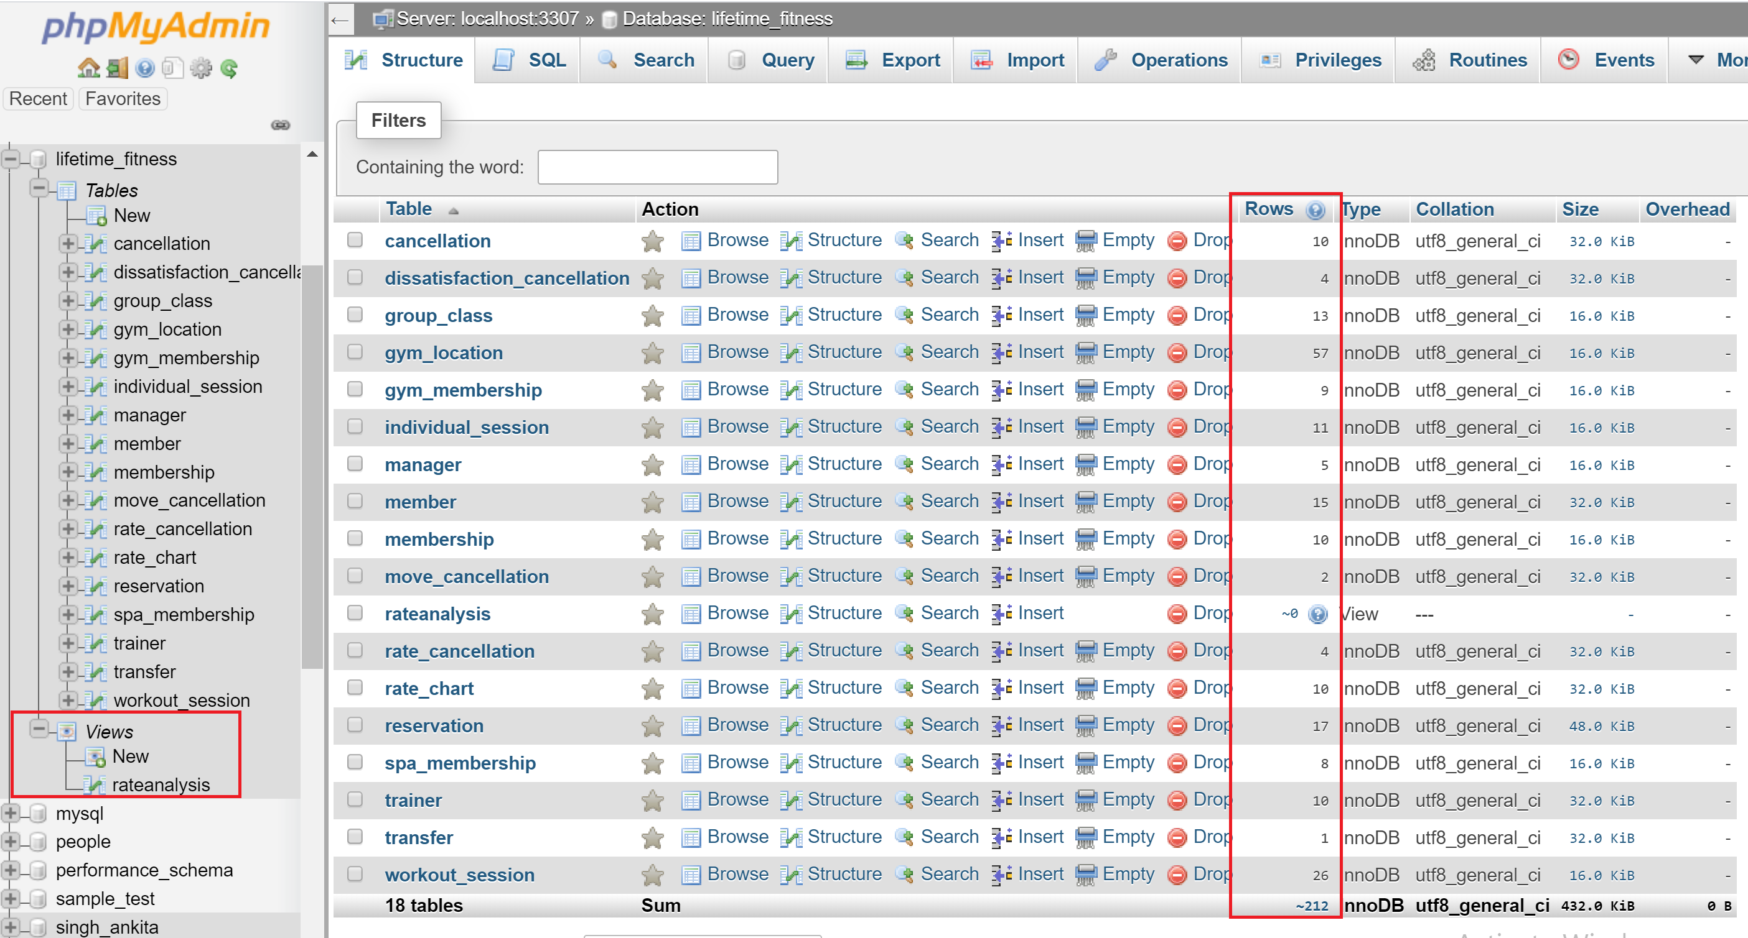

*Figure 7: Data Inserted into Lifetime Fitness Database*

## 3.2.2 DML SQL: Write SQL Queries

**STORED PROCEDURE EXECUTION COMMANDS (Refer SP created in section 3.1.2)–**

**Scenario 1,2 and 3: Gym Operations Performance Analysis Based on Member’s Feedback**

**Scenario 1**: CALL SP_TRAINER_PERFORMANCE1('Training Issue');

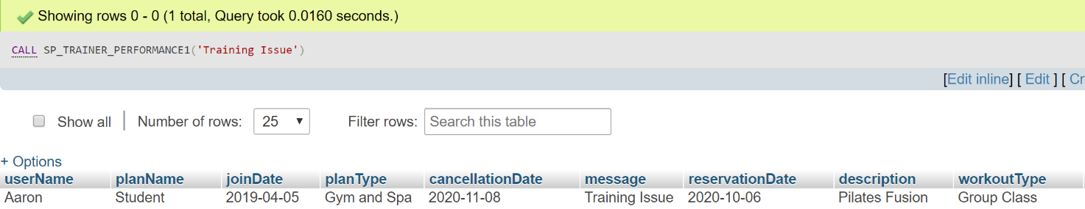

**Scenario 2**: CALL SP_TRAINER_PERFORMANCE1('Problems with the Service');

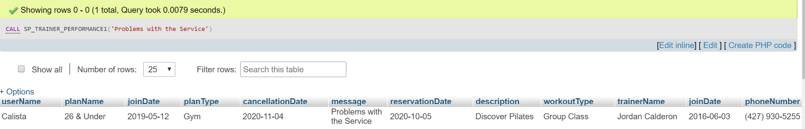

**Scenario 3:** CALL SP_TRAINER_PERFORMANCE1('Problems with the Product');

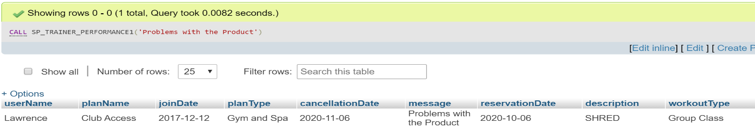

## **Scenario 4**: Total count of gym members retained and churned grouped by reason of cancellation and final deicison made

SELECT

C.reason,C.finalDecision,

SUM(CASE WHEN R.rateID IS NOT NULL THEN 1 ELSE 0 END) AS RATE_MEMBER_COUNT,

SUM(CASE WHEN D.managerID IS NOT NULL THEN 1 ELSE 0 END) AS DISSATISFACTION_MEMBER_COUNT,

SUM(CASE WHEN M.locationID IS NOT NULL THEN 1 ELSE 0 END) AS RELOCATION_MEMBER_COUNT

FROM cancellation AS C

LEFT JOIN rate_cancellation AS R ON R.rCancellationID=C.cancellationID

LEFT JOIN dissatisfaction_cancellation AS D ON D.dCancellationID=C.cancellationID

LEFT JOIN move_cancellation AS M ON M.mCancellationID=C.cancellationID

WHERE C.cancellationDate > '10-OCT-2020'

GROUP BY

C.reason,

C.finalDecision

ORDER BY C.reason DESC, C.finalDecision ASC;

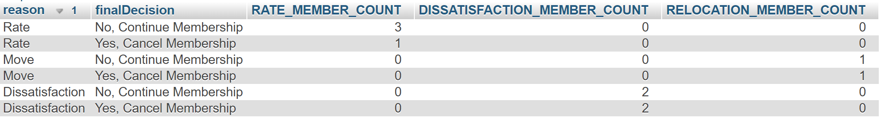

**Scenario 5**: Duration of Association of members with the Gym using DATEIFF function

SELECT M.memberFirstName,M.planID, M.joinDate,MS.planName, C.cancellationDate,

DATEDIFF( C.cancellationDate,M.joinDate) AS DURATION_IN_DAYS

FROM member AS M

INNER JOIN cancellation AS C ON M.memberID=C.memberID

INNER JOIN membership AS MS ON M.planID=MS.planID

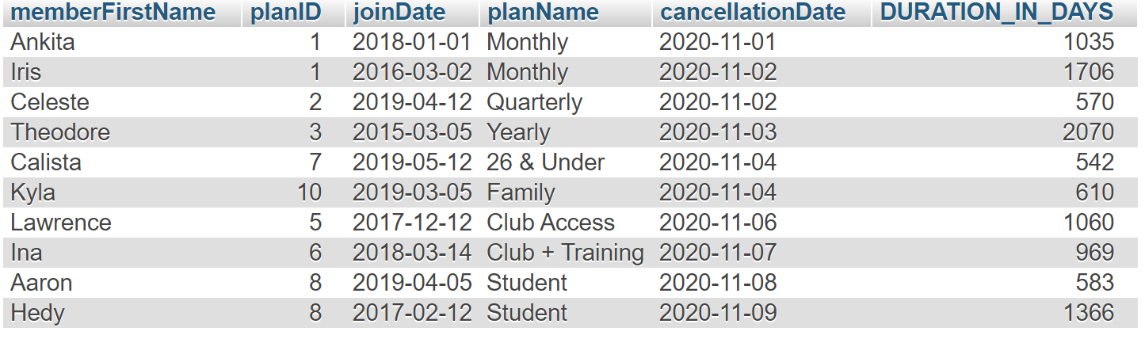

**Scenario 6**: Display the member, cancellation and manager details when the member initiate cancel request due to Training Issue, Problems with the Service, Problems with the Product

SELECT M.memberFirstName, C.cancellationDate , D.managerID

FROM dissatisfaction_cancellation AS D

INNER JOIN cancellation AS C ON C.cancellationID=D.dCancellationID

INNER JOIN member AS M ON M.memberID=C.memberID

WHERE D.message IN ('Training Issue','Problems with the Service','Problems with the Product');

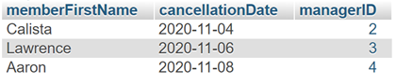

**Scenario 7**: Service Analysis view to analyze the reason for dissatisfaction and Manager’s effectiveness **(Refer Views created in section 3.1.2)**

**SELECT * FROM serviceanalysis**

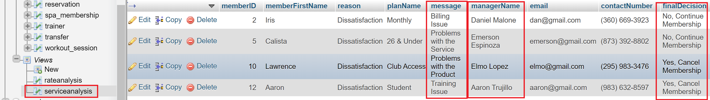

**Scenario 8**: Rate Analysis view for customer churn analysis **(Refer Views created in section 3.1.2)**

**SELECT * FROM rateanalysis**

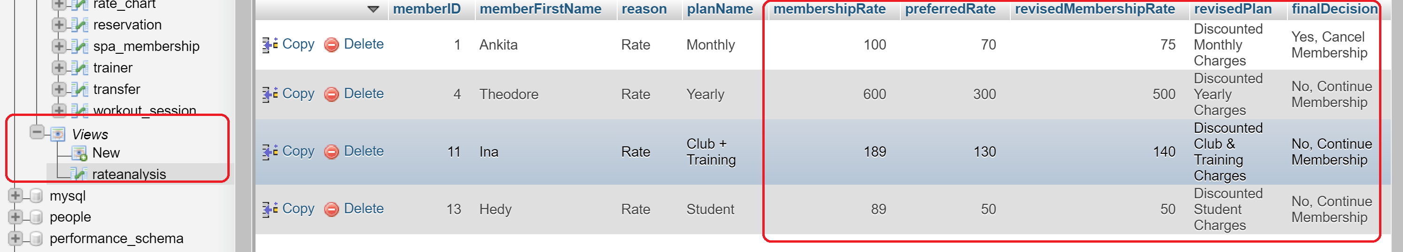

**Scenario 9:** Location Analysis view for identifying opportunities to increase revenue **(Refer Views created in section 3.1.2)**

**SELECT * FROM locationanalysis**

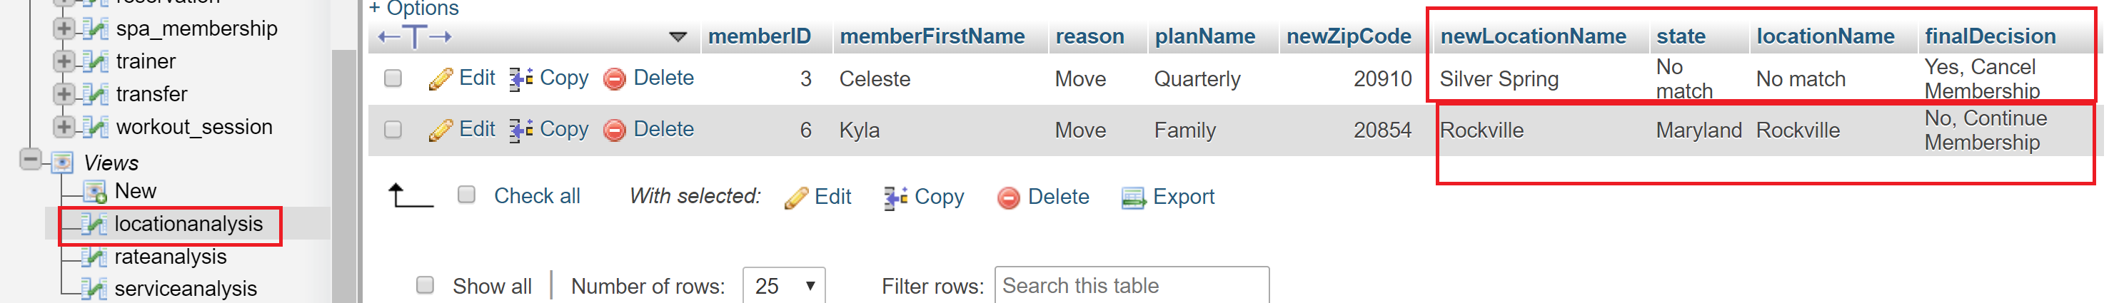

**Scenario 10:** Retrieve member and plan details by joining Member and Membership tables to display the users who have permanently canceled lifetime fitness membership

SELECT M.userName,M.memberLastName, M.emailAddress,M.planID,M.joinDate,MS.planName,MS.membershipRate,MS.signUpFee,MS.planType

FROM member M

INNER JOIN membership MS

ON M.planID=MS.planID

WHERE M.memberID IN

(SELECT C.memberID FROM cancellation C WHERE C.finalDecision = 'Yes, Cancel Membership');

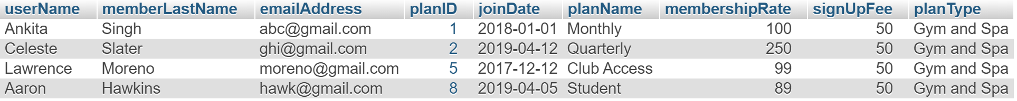

**Scenario 11:** Get the Member details enrolled in ‘Group class’ workout sessions

SELECT G.className,G.classSize,W.duration,W.workoutTime,W.description,W.workoutType,M.memberFirstName,

M.memberLastName,R.reservationDate

FROM group_class G

INNER JOIN workout_session W ON W.workoutID=G.gworkoutID

INNER JOIN reservation R ON R.workoutID=W.workoutID

INNER JOIN member M ON M.memberID=R.reservationID

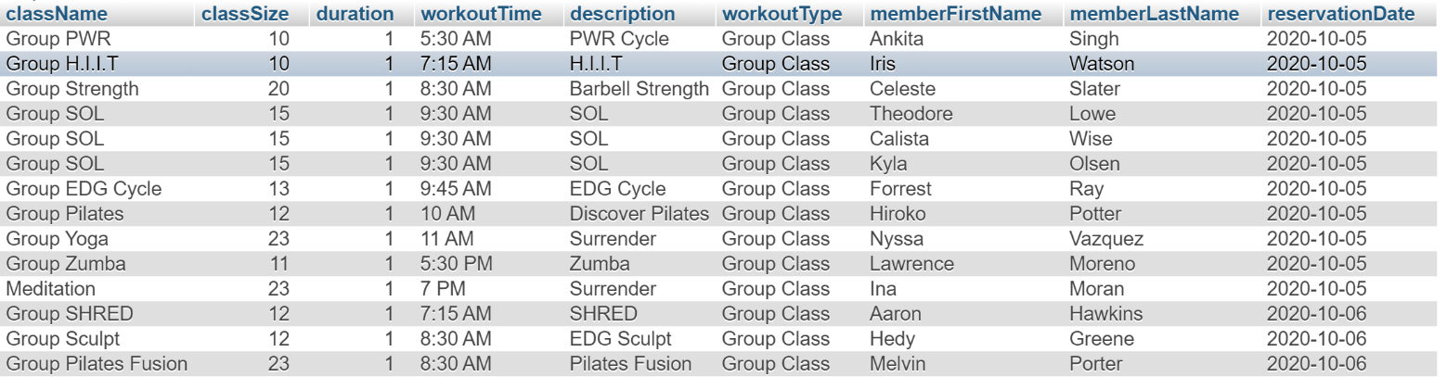

**Scenario 12:** Get the Gym equipments and Spa service information for the members who have requested for membership cancellation

SELECT M.memberFirstName,M.memberLastName,MS.planName,MS.planType,G.equipmentSeries,S.service,

C.cancellationDate,C.reason

FROM member M

INNER JOIN cancellation C ON C.memberID=M.memberID

INNER JOIN membership MS ON M.planID=MS.planID

INNER JOIN gym_membership G ON G.gplanID=MS.planID

INNER JOIN spa_membership S ON S.splanID=MS.planID

